
Anti-Bullying Policy

Review Cycle |  | Annual
Policy / Procedure Owner  *Owner has overall responsibility for this document |  | Headteacher
Reviewed by: |  | Proprietor
Responsible Person  (if different to Policy / Procedure Owner)  *This person has responsibility for maintaining document, communicating changes and staff training where appropriate |  | Cheryl Power  David Butcher
Revision record
Revision No. | Date of Issue | Reason for Revision
1 | 05/09/25 | Annual review  Next review 04/09/26

With reference to:

“Preventing and Tackling Bullying” DfE July 2017:
“Some forms of bullying are illegal and should be reported to the police. These include:
- violence or assault
- theft
- repeated harassment or intimidation, for example name calling, threats and abusive phone calls, emails or text messages
- hate crimes

All schools should have a behaviour policy in place that includes measures to prevent all forms of bullying among pupils.
This policy is decided by the school. All teachers, students and parents must be told what it is.
Schools must also follow anti-discrimination law. This means staff must act to prevent discrimination, harassment and victimisation within the school. This applies to all schools in England.”

These documents build upon:

“Keeping Children Safe in Education”, September 2024
“Working Together to Safeguard Children”, December 2023
“Tackling Race and Faith Targeted Bullying; a guide for schools”, May 2017
“Preventing and Tackling Bullying”, July 2017
“Cyberbullying : Advice for Headteachers and school staff””, Nov 2014
“Advice for parents and carers on Cyberbullying”, Nov 2014

Independent School Standards Regulations, 2019
Equality Act, 2010 – and amendments 2024

Equality Duty. Part 6 of The Equality Act, 2010/2024 makes it unlawful for the responsible body of a school to discriminate against, harass or victimise a student or potential student in relation to admissions, the way it provides education for students, provision of student access to any benefit, facility or service, or by excluding a student or subjecting them to any other detriment.

Key Principles: We believe that:

- Every student has a right to learn without fear of intimidation or exploitation.
- Students learn best when they feel comfortable, confident and a valued member of the school community.
- Our school community functions most productively when individuals accept collective responsibilities and everyone works to provide a therapeutic environment in which the needs of all individuals are of equal importance.

A definition: What is bullying?

Bullying is behaviour by an individual or group, repeated over time, that intentionally hurts another individual or group either physically or emotionally. Bullying can take many forms (for instance, cyber-bullying via text messages, social media or gaming, which can include the use of images and video) and is often motivated by prejudice against particular groups, for example on grounds of race, religion, gender, sexual orientation, special educational needs or disabilities, or because a child is adopted, in care or has caring responsibilities.

“Stopping violence and ensuring immediate physical safety is obviously a school’s first priority but emotional bullying can be more damaging than physical; teachers and schools have to make their own judgements about each specific case.
Many experts say that bullying involves an imbalance of power between the perpetrator and the victim. This could involve perpetrators of bullying having control over the relationship which makes it difficult for those they bully to defend themselves.”
(DfE 2017: Preventing and Tackling Bullying).

Most definitions of bullying (ref. DfE Preventing and Tackling Bullying, 2017) involve acts that are:
- Intentionally hurtful – to another individual or group - either physically or emotionally
- Repeated over time
and are acts that may be:
- Difficult for victims to defend themselves against

Can take many forms:
- Physical – hitting, kicking, theft
- Verbal – name calling, insulting, offensive remarks ( ethnic origin, nationality, colour, sexual orientation, disability)
- Indirect – nasty stories about someone, malicious rumours, malicious Emails or mobile phone text messages (and abuse via other forms of social messaging media – see cyberbullying policy and search policy).
- It is also important that school staff recognise peer on peer bullying/abuse, including sexual harassment and exploitation.

At Huntingdon House School, we regard bullying as one or more of the following:

- Intimidation: exerting pressure on another individual to behave in a manner opposed to his/her wishes.

- Initiating physical violence, verbal violence or threats against another person.

- Social isolation: using lies to discredit someone.

More subtle forms of bullying or collusion are unlikely to apply within the peer group; staff will use the day-day monitoring of well-being levels as a first alert to the possibility of incidents of bullying in its many forms.

Students may perceive bullying in different ways. Any situation with which they are not comfortable may feel like bullying. Any racial, sexual or homophobic name calling and inappropriate touching will not be tolerated, even when these labels and actions are applied without any real understanding. This includes cyberbullying as well as real-time bullying. Teasing and nick-names are to be avoided due to the risk of student hypersensitivities. Staff will work with small groups of students throughout most of each day, to help them to manage their behaviour and their sensitivities and to help them to understand the many ways that other people can feel vulnerable.

It is important that staff recognise and understand the difference between poor/immature social skills and deliberate bullying behaviours, and to react accordingly. Where the bullying is persistent, continually targeted at a particular child/group or is sustained then staff will respond more severely than when a child inadvertently ‘mishandles’ a social situation through lack of empathy or experience. No matter what the cause of the bullying, ALL bullying behaviours will be dealt with promptly and recorded on the Bullying Record Sheet (Appendix A)and in the Bullying Incident Book, although the nature of the response will reflect intent as well as cause and effect.

The Equality Act, 2010/24 includes the following in its duties to protect:

- Homophobic bullying
- Gender and Gender reassignment bullying
- Age bullying
- Racial (or belief) bullying
- Religious and cultural bullying
- Social exploitation and/or isolation due to Special Educational Needs and disability

Cyberbullying

Students in this school may easily become obsessed with social media platforms and do not yet have the maturity or emotional confidence to deal appropriately with perceived criticism or manipulation by others with whom they choose to talk. Too often students find themselves talking to strangers over the internet, on mobile telephones or on social media (sometimes late at night), without adequate adult supervision, about issues that leave them vulnerable to abuse. For students who find friendships difficult and who lack the ability to be selective in their relationships, this poses a real risk.

Cyberbullying involves all areas of the internet, such as email and social media misuse; mobile threats by text messaging and calls; misuse of associated technology i.e. camera and video facilities. (Ref. Kidscape anti-bullying policy for schools)

For the above reasons there are a number of safeguards in place at school to help students to deal with cyberbulling:

- Students are not allowed unsupervised access to the internet in school time.
- Students may bring mobile telephones to school, but these must be handed over to staff for safe keeping at the beginning of the school day and will be handed back to students at the end of the day. Students are not allowed to send or receive mobile ‘phonecalls or texts during the school day, unless with prior arrangement with a member of the Senior Leadership Team due to (for example) a family emergency. (Mobile telephones will be confiscated by staff when they are not willingly handed in for safe keeping).

These procedures also constitute our ESafety Policy

- Parents are advised to supervise carefully a student’s access to the internet at home, this includes the conversations their child has with others when engaged in on-line gaming. Parents are also advised to monitor carefully the conversations and texts their children send and receive on their mobile telephones. When instances of late night and/or worrying conversations on social media or mobile telephones are disclosed by students in school, these are immediately shared with parents/carers and/or Social Services.
- Students are made aware of instances of ‘cyber-bulling’ and ‘grooming’ via social media, texts and mobile phones and are taught not to trust everything that they are told by someone they don’t know and have never met. Media articles about the dangers of relationships established over social media are regularly shared with students and discussed during PSHE lessons.
- When ‘talking’ over the internet with people they already know and trust, students are encouraged to check that the person they are messaging really is the person they think they are…. ask a question only you and your friend know the answer to; set up a password; make arrangements when to email each other when you meet and don’t respond to invitations to ‘talk’ at other times; don’t let unknown others join in your conversations; give your friend a phone call/text to check that it really is them with whom you are talking.
- Students are taught not to share their pictures, name and address or other personal information with others via social media.
- Students are regularly given opportunities to disclose to their Lead Teachers at school in confidential, 1-1 situations any worries or concerns about things they have read, seen or been involved in via internet, social media or mobile telephone texts.
- Students are encouraged to keep a record of, ‘screenshot’ or ‘save’ any distressing emails/texts sent from others and to show these to parents/carers/teachers/other trusted adults.
- Parents and school staff are advised to report any distressing messages, particularly if these are persistent, immediately to the police and/or Social Services.
- When distressing messages are reported to have been sent between students who both attend our school, these incidents will be treated in the same way as any other form of bullying behaviour.
- Students are taught that ‘cyber-bullying’ is unacceptable and that they must NOT SUFFER IN SILENCE.

Aims:
We aim to:
- Ensure that all members of the school community understand what bullying is and are aware of the school’s anti-bullying policy and preventative procedures.
- Promote the contributions of all members of the school community to the regular evaluation, review and development of the school’s anti-bullying policy.
- Provide formal and informal opportunities for pupils, parents and staff to report incidents of bullying (both on and off school site).
- Take all reports of bullying seriously and ensure that they are appropriately recorded.
- Secure monitoring, evaluation and follow-up on all anti-bullying measures to prevent incidence and reoccurrence.

Strategies to combat bullying:
Preventing and Tackling Bullying, 2017 raises the importance of:

- Prevention
- Intervention

“Schools should be able to demonstrate the impact of anti-bullying policies.” (DfE, July 2017: Preventing and Tackling Bullying)

- Preventing bullying:

A curricular response:

To prevent the incidence of bullying, learning opportunities across the curriculum should:

          - Promote positive relationships across the curriculum.
          - Encourage the development of students’ social skills and awareness.
          - Raise awareness about bullying and the school’s Anti-Bullying Policy.

Each student will have their own learning timetable each day/week. This will be complemented by some larger group timetabled activities throughout the week (e.g. PE and PSHE). Planned activities will frequently be cross-curricular in nature and will often have at least one learning target that refers to a student’s personal, social and emotional development. The formal and/or informal day-to-day assessment of a student’s well-being and involvement will help staff to set appropriately challenging PSE learning targets.

The curriculum:

The curriculum at Huntingdon House School is designed to promote independent learning, self-motivation and self-discipline. The intensive support offered students by their dedicated Lead Teachers will help them to concentrate, persevere and to work with confidence and comfort alongside and with other students in small group situations. Basic social skills such as sharing and turn-taking will be reinforced across the curriculum and students will be encouraged at all times to be alert to the interests and perspectives of others, as they work in close proximity in a variety of practical workshop areas. Through frequent, timetabled circle-time activities with slightly larger groups, students will be introduced to structured learning associated with PSHE, including an exploration of what we mean by bullying, why people bully others and how bullies and victims can be encouraged to develop new and more effective social behaviours and relationships. Students will be reminded on a regular basis how they can report an incident of bullying, what the procedures are and who can help.

Students will also be encouraged to develop an understanding of others through topic work associated with subjects such as history, geography, drama and health education; reinforced through regular visits into the ‘real world’ and visitors who will share their skills, interests and talents with the students. Multi-agency working with local community support services (such as the police, fire brigade etc.) will feed into topics and themes being developed in the curriculum and will provide opportunities for parents/carers to engage in these learning experiences with their children. As the students refine and develop their social skills, activities will be presented that promote collaboration and cooperation.

Anti-social behaviour (damage, injury or theft) will always be actively discouraged and follow-up will always include a dialogue that promotes an understanding of others as well as the recognition of boundaries and appropriate behaviours. The deliberate exploitation and/or intimidation of others (physically, verbally or emotionally) will elicit direct action and implementation of the school’s Anti-Bullying policy procedures.

Each student’s IECP will have targets to promote their PSHE development, these will be shared with parents/carers via. weekly curriculum targets and discussed at regular intervals throughout the year when a child’s progress is reviewed. Parents will be supported in their behaviour management skills, through opportunities for training and discussion with their child’s Lead Teacher. Every effort will be made to ensure that self-control and self-discipline are integrated across the curriculum for all students and that parents/carers are kept fully informed and involved in their children’s social learning and development.

Recording incidents of bullying: see bullying record sheets attached and Bullying Incident Book

- Dealing with bullying/ Intervention

5 key points: Never ignore suspected bullying:
- Don’t make premature assumptions.
- Listen carefully to all accounts – several students saying the same does not necessarily mean they are telling the truth.
- Adopt a problem-solving approach which moves students on from justifying themselves.
- Follow-up repeatedly, checking bullying has not resumed.
- Involve parents/carers.

Many/most students at Huntingdon House School will experience social and behavioural difficulties. In light of this we will do all we can to ensure that students are not put into social situations that they are unable to handle. Many students may be socially and emotionally immature and/or may be recreating relationships and behaviours they have personally experienced. We will operate a no-blame approach to bullying wherever possible and will give students (both bully and victim) opportunities to learn new ways of interacting positively with others. However, bullying will not be tolerated and where students are unable to make changes to their destructive relationships, we must protect vulnerable children and will be prepared to apply exclusion sanctions in extreme situations.

Distinguishing between alleged and substantiated bullying involves a structured investigative process to ensure fairness and accuracy. Here's an overview of how the school will handle this:
1. Reporting the Allegation
- Immediate Action: Staff members are required to report any instance of bullying or retaliation to the Headteacher or designated DSL promptly.
2. Initial Assessment
- Understanding the Complaint: The Headteacher / designated staff member discusses the nature of the alleged bullying with the reported victim, recording all relevant details.
3. Gathering Evidence
- Identifying Involved Parties: The investigator identifies the alleged bully or bullies and any witnesses to the incident.
- Conducting Interviews: Separate interviews are held with the victim, alleged perpetrator(s), and witnesses to gather comprehensive accounts.
4. Evaluating the Evidence
- Assessing Consistency: The investigator reviews the collected statements for consistency and credibility.
- Considering Context: Factors such as the frequency and severity of the alleged behaviour, power imbalances, and the impact on the victim are evaluated.
5. Making a Determination
- Substantiating Bullying: If the investigation confirms that bullying occurred, appropriate actions are taken to address and prevent further incidents.
- Unsubstantiated Allegations: If evidence is insufficient or inconclusive, the allegation remains unsubstantiated, but monitoring and support may continue.
6. Communication and Follow-Up
- Informing Parties: Both the victim and the alleged perpetrator, along with their parents or guardians, are informed of the investigation's outcome and any ensuing actions.
- Ongoing Support: Regardless of the outcome, support mechanisms are provided to all parties involved to promote healing and prevent future issues.

Staff guidance

Staff members are expected to be vigilant to the various forms that bullying can take and to intervene at the first hint of bullying between students and their peers (and any bullying by or between staff – Ref. Equality Act, 2024). For students with learning difficulties intervention needs to be immediate and simple. However, diversion tactics or refocusing students on their learning in a non-confrontational manner could prove helpful in the first instance. If the bullying continues staff will need to interrupt the behaviour more sharply. Separation of the bully from the bullied will need to take place and it may be necessary to alert further staff to affect this. It is important that staff do not dismiss the behaviour as inconsequential squabbles. Most, if not all of our students, will have been victims of bullying. Many may have bullied others, perhaps without realising the effect they have on others. Huntingdon House is committed to the highly challenging task of changing both situations and helping children to move towards self-assertion and respect for others. To these ends students will not be unsupervised, even during leisure periods. Staff are asked to be alert at all times to untimely or uncharacteristic signs of stress in individual children. A Lead Teacher system that promotes a close and trusting relationship between each student and an individual member of staff will help to facilitate this.

The nurturing environment of the school, as well as the spontaneity of the students, promotes the likelihood that all students (and visitors) who observe an incident of perceived bullying will feel empowered and entitled to confide in staff. Some students will be very attuned to the role of the victim and maybe even set themselves up as such. Open staff/student communication is the key to establishing a culture of honesty and inter-dependence.

“Copy-cat” bullying is to be deterred by means such as ignoring unwanted behaviour, diverting and rewarding more socially appropriate behaviour with staff attention. It is not envisaged that students at Huntingdon House will have the group skills to maintain a delinquent merger. The emphasis throughout the learning environment will be upon individual, scaffolded activity with a teacher in carefully supported and monitored small group situations, designed to inhibit opportunities for bullying and to respond quickly should the potential for this situation occur.

Anxiety is often at the root of bullying. The task is to work with the bully towards reparation(restorative Justice). Counselling the bully as well as the victim is relevant. It is to be hoped that, in time, other children may be able to help support the victim and even be instrumental in effecting a change for the bully. However, before children can help others to feel safe they have to understand how to keep themselves safe.

Sometimes students may attempt to intimidate staff. Staff will be expected to respond in a non-retaliatory manner but to refuse the victim-role, involving other staff as necessary to ensure the physical and emotional safety of the adults and children. In the event that a child perceives he or she is being bullied by an adult, or a member of staff is concerned about the behaviour of an adult towards the child, Complaints procedures and / or Child Protection procedures will be invoked.

Staff should ensure that all observed or reported bullying is appropriately recorded in the incident book before the end of the day and brought to the attention of the full staff team at the weekly team meeting.

Stage 1: Awareness raising and consultation

A policy will only be effective if everyone in school has discussed and understood the problem of bullying, agreed on a definition and what constitutes good and bad practice. In order to reach this consensus, there will be:
- Training for all newly appointed staff during their induction, with opportunity for staff to work through the school’s anti-bullying procedures with the support of a member of the senior management team. New staff will be provided with a copy of Huntingdon House’s anti-bullying policy and opportunity will be provided for newly appointed staff to engage in a whole school discussion around this policy at a full staff meeting during their first term.
- All new students and their parents/carers will receive a copy of the Huntingdon House’s anti-bullying policy and will be provided with opportunity to raise comments, questions and suggestions and to discuss issues arising with appropriate members of staff. A record of concerns and suggestions will be kept with the anti-bullying policy and will be used to inform discussion and debate when the policy is next reviewed.
- All parents/carers will be provided with a copy of the school’s Anti-Bullying Policy (and Behaviour Policy) during their child’s first term in school. Parents will also be invited to an anti-bullying meeting at the beginning of each academic year, when they can discuss together their concerns and share their experiences. Parents will be encouraged to share with staff any incidents of bullying outside of school premises. Staff at this meeting will make clear the links between bullying behaviour, immature social skills and behaviour management strategies (including reference to the school’s behaviour management policy).
- Each student and their parents/carers will be invited to a meeting with their Lead Teacher during their first term in school to review the student’s experiences and achievements to date – attitudes and relationships (including bullying) will be an important part of discussions at this meeting and will be revisited at regular meetings throughout the year (minimum of each term once the student is full-time).
- Questionnaires will be offered to staff, pupils and parents at the end of a student’s first term in school and again for all students, parents and staff on an annual basis. These questionnaires will be used to identify if, when, where and how incidents of bullying have taken place. They will also collate the perspectives of all members of the school community about the effectiveness of the anti-bullying policy. Results of the questionnaires (whilst anonymous) will be discussed in termly review meetings and student support groups and the policy will re-drafted as necessary. See Appendices B,C,D.

Stage 2: Implementation of the Anti-Bullying Policy

Sanctions

The dedicated nature of this school for students with special educational needs and learning difficulties is likely to mean that bullying is a regular topic for discussion between students and staff. Sanctions for bullying behaviour will increase in severity with persistence and intensity. All staff responses to bullying will be immediate, predictable and will engage both the victim and the bully, although not necessarily always at the same time.

Levels of response:

Level 1:

Mediation: Staff encourage a two-way dialogue between victim and bully and model alternative behaviours (restorative Justice, away from the activities and other students if necessary); the victim is supported in communicating to the bully their feelings and the consequences of the bully’s behaviour. Reparation: the bully is encouraged to take stock of their actions and the effects on others even if unintentional, and apologise.
Follow-up: staff tracks more carefully this relationship over the coming days / week to check for reoccurrences.

Level 2:

Skills development: Staff work with the bully and the victim separately. If an incident is taking place: the bully is withdrawn from the situation (time-out) and behaviour boundaries are re-established. With staff structuring the discussion, the bully is encouraged to reflect upon their behaviour and to consider consequences and possible alternative actions. Clear expectations are established for future behaviour, with clear penalties (loss of privileges) if these behaviours are breached again.
At a convenient point after the incident, the victim is encouraged to reflect upon how their behaviour may have incited the bully, and how they can better avoid confrontation in the future (communication skills, body language etc.).
Follow-up: Staff track the relationship with daily reviews involving both the bully and the victim until the relationship is improved. If at the end of a week the relationship is not improved and the risk of bullying remains high, the incident moves to Level 3. Parents/carers and headteacher are informed.

Level 3:

Discipline: A persistent bully is denied access to ‘high risk’ situations/activities. A behaviour management action plan is established that addresses the attitudes, emotions and beliefs that underpin the behaviour. Parents/carers and if necessary, an educational psychologist are involved. Other support services may be involved as appropriate. Daily targets are set and reviewed. Failure to achieve these targets will result in immediate exclusion from the school site (sometimes for sustained periods), failure to make improvement over time will result in permanent exclusion from school. Where there is improvement, the bullying behaviour must be controlled within a two-week period, although behaviour modification programmes may continue beyond this.
Work with the victim will be on-going with regular daily reviews and support meetings. Support networks will be encouraged, engaging other students, parents/carers and sometimes also outside agencies as well as staff.

One term later:
At all levels, there will be a final completion meeting with bully and victim approximately one term after the satisfactory resolution of a bullying incident. Once it has been confirmed that the bullying has stopped, the incident form is delivered to the headteacher to ‘sign off’.

Stage 3: Monitoring

Monitoring of Anti-Bullying procedures will be undertaken by members of the Senior Management Team (headteacher and/or welfare manager), the results of which will be discussed at a full staff meeting at least once each year, or sooner if deemed necessary. All reported incidents of bullying will be recorded in the Bullying Incident Book using the Bullying record Sheet (Appendix A). Entries in this book will be monitored each half-term by the headteacher and/or welfare manager. Lead Teachers will monitor bullying more closely on a week-by-week basis for the individual children in their care. Individual cases of bullying will be referred directly to the headteacher if they are not satisfactorily resolved within a fortnight. All bullying records will be retained for a minimum of one calendar year following the satisfactory resolution of all incidents within the book. Parents may request the specific details of incidents of bullying involving their children, but the names of students other than their own child will be kept confidential.

Stage 4: Evaluation

The Anti-Bullying Policy will be reviewed termly at a full staff meeting. Data from the Bullying Incident Book, from pupil, parent and staff questionnaires and from informal feedback will be used to evaluate how well the school’s policy ensures that:
- staff are vigilant and responsive to bullying
- students report being bullied or that they bully others
- incidents of bullying are appropriately recorded, monitored and acted upon
- students say they would not join in bullying someone else
- students would tell a member of staff if they were being bullied.

Following this review, at the end of each term an evaluation report will be provided for Proprietor, parents, students and staff.

LEVEL 1

Staff mediation
- staff intervention controls the situation, models more appropriate actions and helps students to communicate their thoughts and feelings
- immediate solution: relationship improved
          - no reoccurrence at the end of 1 week

          - if there is a reoccurrence of bullying during this week, then the incident moves to Level 2

LEVEL 2

Skills development
          - bully withdrawn from incident, both bully and victim offered support and social skills development
          - sanctions used initially to prevent bully from re-offending (loss of privileges)
          - daily reviews
          - relationship improves
          - no reoccurrence by the end of 1 week and sanctions no longer required

          - no improvement at the end of 1 week moves incident to Level 3 with parents/carers and headteacher informed.

LEVEL 3

Discipline
          - time limit set for improvement (max. 2 weeks)
          - social skills training continues
          - development of support networks to include other students, parents/carers and sometimes also outside agencies as well as staff
          - sanctions used to prevent bullying may also include (temporary or permanent) exclusion from school
          - daily reviews, involving member of SLT
          - risk of bullying is reduced from a moderate/high risk to low/no risk by the end of a 2 week period

          - if at the end of the 2 weeks, the risk of bullying is not significantly improved then it will be dealt with by the headteacher.
EXCLUSTION

A timeline for implementation of our Anti-Bullying Policy

Induction
Students, parents and staff new to the school are provided with a copy of the school’s anti-bullying policy, together with behaviour policy.

Awareness raising and discussion of school’s anti-bullying policy
and procedures:

Students and parents invited to discuss policy with headteacher as part of their introduction to school.

Newly appointed staff are supported by SLT in working through Anti-Bullying Policy and Procedures to share aims, strategies and perspectives.

Newly appointed staff invited to discuss policy at whole school staff meeting and are invited to complete a bullying questionnaire at the end of their first term.

During a student’s

first term
Bullying questionnaire completed by student and parents/carers.

First Lead Teacher/parent/student review meeting: discussion includes reference to behaviour management and bullying policies.

Half-termly
Bullying continues to be raised as an issue for discussion at Lead Teacher/parent/student termly review meetings.

Bullying incident book is monitored by SLT.

Interim review of Anti-Bullying Policy at a full staff meeting: feedback from monitoring of incident book.

Review of curriculum plans to secure the integration of anti-bullying measures across the curriculum for all students.

Termly
Findings from monitoring of incident book published in school’s termly report, copies sent to staff, students, parents/carers and Proprietor.

Annually

Bullying questionnaires to students/parents/staff (Spring Term)

Policy revised at full staff meeting (Summer Term)

Parents invited to an anti-bullying meeting to discuss the revised policy (beginning of new academic year)

Staff performance management: identification of in-service support for individual staff (when PM targets are set)

School Improvement Planning (Summer Term)
:identification of in-service support for whole school.
: identification of relevant resources.
: development of ‘high risk’ locations on school site.
Monitoring and Evaluation:
Monitoring of the bullying policy:
- Policy review and update annually
- Termly report to Proprietor, parents/carers and staff (published as a regular article in the school’s termly newsletter) to ensure that:
- staff are vigilant and responsive to bullying
- students report being bullied or that they bully others
- students say they would not join in bullying someone else
- students tell a member of staff if they were being bullied

Monitoring procedures:

What?

Recording of all incidents of bullying in the Bullying Incident Book

Tracking the satisfactory solution of each bullying incident at 3 levels

Regular monitoring of incidents and termly feedback to Proprietor, parents and students

Annual distribution and collation of bullying questionnaires

Annual policy review and development

By whom?

All staff checked by SLT

Lead Teacher @ L1 + L2 checked by line manager

Headteacher @ L3

SLT

SLT

Useful links and supporting organisations
• Anti-Bullying Alliance: www.anti-bullyingalliance.org.uk
• Childline: www.childline.org.uk
• Family Lives: www.familylives.org.uk
• Kidscape: www.kidscape.org.uk
• MindEd: www.minded.org.uk
• NSPCC: www.nspcc.org.uk
• The BIG Award: www.bullyinginterventiongroup.co.uk/index.php
• PSHE Association: www.pshe-association.org.uk
• Restorative Justice Council: www.restorativejustice.org.uk
• The Diana Award: www.diana-award.org.uk
• Victim Support: www.victimsupport.org.uk
• Young Minds: www.youngminds.org.uk
• Young Carers: https://carers.org/about-us/about-young-carers
• The Restorative Justice Council: https://restorativejustice.org.uk/restorative-practice-schools

SEND
• Changing Faces: www.changingfaces.org.uk
• Mencap: www.mencap.org.uk
• DfE: SEND code of practice: www.gov.uk/government/publications/send-code-of-practice-0-to25

Cyberbullying
• Childnet: www.childnet.com
• Internet Watch Foundation: www.iwf.org.uk
• Think U Know: www.thinkuknow.co.uk
• UK Safer Internet Centre: www.saferinternet.org.uk
• The UK Council for Child Internet Safety (UKCCIS)
www.gov.uk/government/groups/uk-council-for-child-internet-safety-ukccis
• DfE ‘Cyberbullying: advice for headteacher/principals and school/college staff’:
www.gov.uk/government/publications/preventing-and-tackling-bullying
• DfE ‘Advice for parents and carers on cyberbullying’:
www.gov.uk/government/publications/preventing-and-tackling-bullying

Race, religion and nationality
• Anne Frank Trust: www.annefrank.org.uk
• Kick it Out: https://www.kickitout.org/take-action/resources
• Report it: www.report-it.org.uk
• Stop Hate: www.stophateuk.org
• Tell Mama: www.tellmamauk.org
• Educate against Hate: www.educateagainsthate.com
• Show Racism the Red Card: http://www.theredcard.org/

LGBT
• Barnardo’s LGBT Hub: www.barnardos.org.uk/what_we_do/our_work/lgbtq.htm
• Metro Charity: www.metrocentreonline.org
• EACH: www.eachaction.org.uk
• Proud Trust: www.theproudtrust.org
• School/colleges Out: http://www.schools-out.org.uk/
Sexual harassment and sexual bullying
• Ending Violence Against Women and Girls (EVAW) www.endviolenceagainstwomen.org.uk
• Disrespect No Body: https://www.gov.uk/government/publications/disrespect-nobody
campaign-posters
• Anti-bullying Alliance: advice for school/college staff and professionals about developing
effective anti-bullying practice in relation to sexual bullying: https://anti
bullyingalliance.org.uk/tools-information/all-about-bullying/sexual-and-sexist-bullying
Note: Additional links can be found in ‘Preventing and Tackling Bullying’ (July 2017)
www.gov.uk/government/publications/preventing-and-tackling-bullying
DfE research into anti-bullying practices:
https://www.gov.uk/government/publications/approaches-to-preventing-and-tackling-bullying

Bullying record sheet – Appendix A

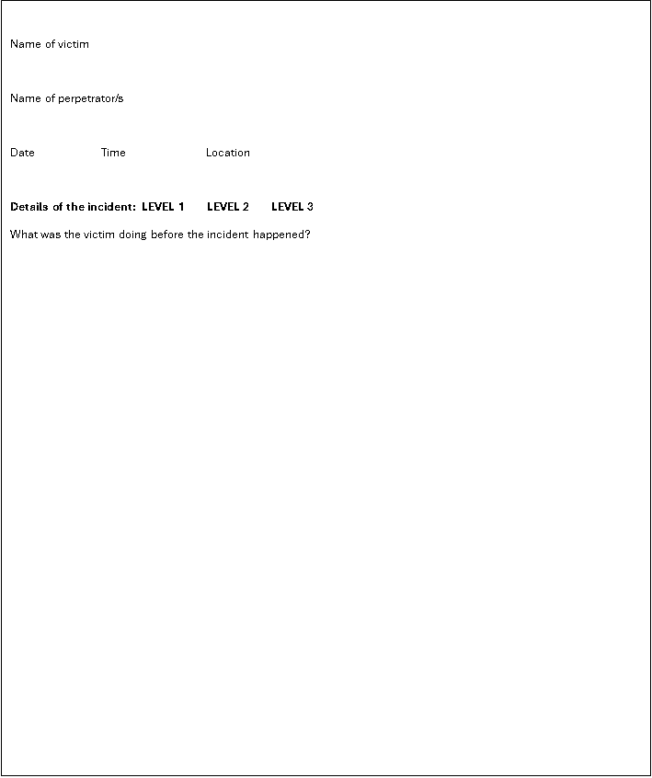

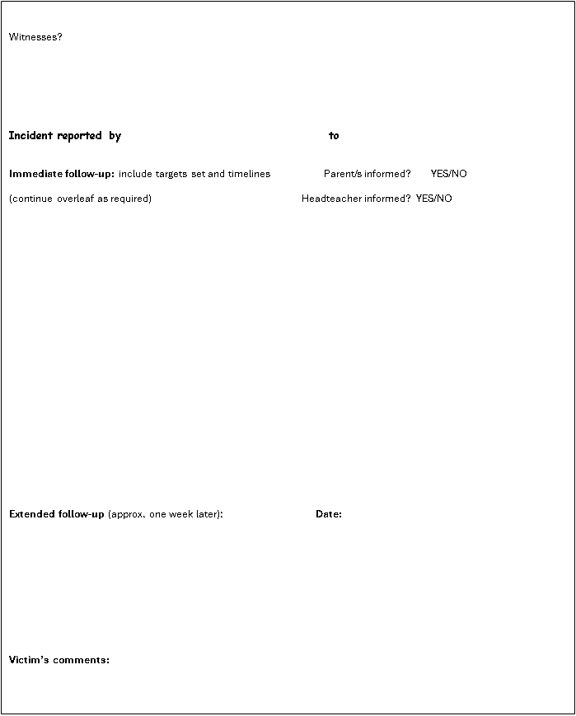

Appendix B
Staff Bullying Questionnaire:

Please tick those responses that are most appropriate.

- How well do you know the school’s Anti-Bullying Policy?
very well quite well not sure

- Are you confident in your ability to identify and deal with incidents of bullying?
confident in all situations confident in most situations not very confident

- How helpful do you find the school’s Anti-Bullying Policy and procedures?
Very helpful helpful a bit confusing

- When writing up incidents of bullying in the Bullying Incident Book, do you find the form relevant to your needs?
Yes No Haven’t had to use one

- Do you feel appropriately involved in designing, reviewing and evaluating the school’s bullying policy and procedures?
Yes No

- Do you feel appropriately informed and supported when expected to
deal with bullying incidents reported to you that may involve students, parents and/or staff?
Please tick all that apply: students parents staff

- Would you feel comfortable reporting the following bullying incidents?
Please tick all that apply: a student being bullied a member of staff being bullied you being bullied

8. When was the last time you undertook any anti-bullying in-service training?
Less than a year ago 1-2 years ago 2-3 years ago More than 3 years ago

- Would you like additional anti-bullying in-service training?
Yes No

10. On a scale of 1-10 (10 being highest), how well do you think our school prevents and deals with incidents of bullying?

Any other comments or suggestions: Please continue overleaf if necessary.

Appendix C
Parents’ Bullying Questionnaire

Please tick those responses that are most appropriate, you may sometimes wish to tick more than one.

- Are you familiar with the school’s Anti-Bullying Policy?
I’ve seen a copy and discussed it with staff I’ve seen a copy of the policy I didn’t know there was one

- When was the last time you discussed bullying with school staff?
very recently fairly recently not at all

- Would you feel confident in reporting to staff an incident in which your child was bullied?
very confident quite confident not very confident

- Would you feel confident in reporting to staff an incident in which your child has been a bully?
very confident quite confident not very confident

- Have you ever had to report an incident of bullying to staff at this school?
Yes No

- Has your child been involved in a bullying incident over the past year?
Yes, I reported it to staff Yes, but I didn’t report it Yes, but the incident was not at school No

- How well do you think this school deals with incidents of bullying?
very well quite well not as well as I would like

- Do you think this school does enough to prevent bullying?
Yes No

- Would you like to be more involved in designing and evaluating the school’s Anti-Bullying Policy?
Yes No

- Do you know where to go to get more information about anti-bullying strategies and support groups?
Yes No

Any other comments or suggestions: Please continue overleaf if necessary.

Appendix D
Student Bullying Questionnaire:

Please tick those responses that are most appropriate, you may sometimes wish to tick more than one.
A member of staff will help you to complete this questionnaire, but you will have to choose all the answers.

- Do you know (can you explain) what bullying is?
Yes No

- Who have you talked to about bullying?
other students staff keyworker headteacher parents/carers other family members

- Would you feel OK about telling staff if you were bullied?
I’d feel fine I’d feel a bit awkward I’d feel very nervous I wouldn’t do it

- Would you feel OK about telling staff if you had bullied another child?
I’d feel fine I’d feel a bit awkward I’d feel very nervous I wouldn’t do it

- Would you feel OK about telling staff if you saw someone else being bullied?
I’d feel fine I’d feel a bit awkward I’d feel very nervous I wouldn’t do it

- Have you been bullied?
Yes, in school Yes, but not in school No

- Do you think staff keep you safe and stop other children in school being bullies?
Yes No Sometimes

- Do you know how to stop other children bullying you?
Yes No

- Do you think that sometimes you are a bully?
Yes No

- If you saw a child being bullied, would you want to help them and know what to do?
I’d want to help and would know what to do I’d want to help but wouldn’t know what to do I wouldn’t want to help them

Any other comments or suggestions: Please continue overleaf if necessary.

